26.69: a) When the switch is open, only the outer resistances have current through them. So the equivalent resistance of them is:
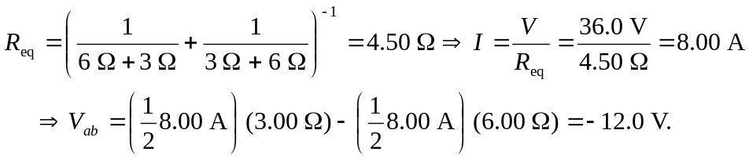
b) If the switch is closed, the circuit geometry and resistance ratios become identical to that of Problem 26.60 and the same analysis can be carried out. However, we can also use symmetry to infer the following:
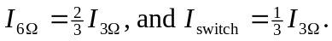 From the left loop as in Problem 26.60:
(c) 